Azure Beachcomer & Cabana News
 | “ABC News”

Aloha! Welcome to Week #7. We have now completed 6 weeks, and…..

BREAKING NEWS! WE HAVE RECEIVED WORD OF A TORNADO WARNING! PLEASE FOLLOW EMERGENCY PROCEDURES WITH YOUR CABANAS IMMEDIATELY!!

:::::::::::::::::::::::::::::::::::::::::::::::::::::::::::::::::: STATIC ::::::::::::::::::::::::::::::::::::::::::::::::::::::::::::::::::

Hello? Is anyone out there? Well, it seems as though our Cabanas have been lifted off to another place and time! Surveying the area around us, I have to say it looks somewhat familiar…. In fact, if I had to guess… yes, I’m sure. Girls, we are in the LAND OF OZ!!
Talk about a Travel Week!

Well, let’s make the most of it! Gather up your things and let’s get on the road to figuring out what we need to do to get home to the Island! Looks like we need to start here at the Yellow Brick Road, and begin!
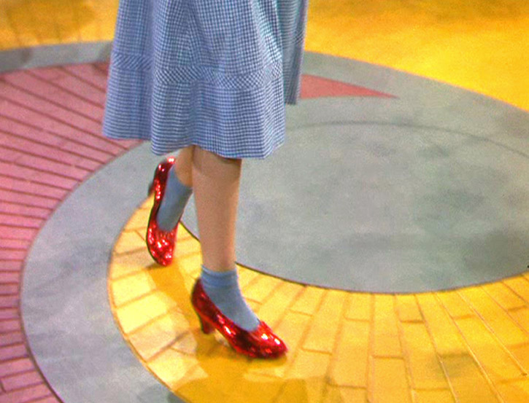



WEEKLY TRACKING SHEET
WED. 10/24 - TUES. 10/30

WEEKLY DATA:

 | WED | THU | FRI | SAT | SUN | MON | TUE | TOTAL
WEIGH-IN |  | XXX | XXX | XXX | XXX | XXX | XXX | XXX
POSTED IN CHAT: | Y/N | Y/N | Y/N | Y/N | Y/N | Y/N | Y/N | ____/7
STRONGend GOALS MET?: | XXX | XXX | Y/N | Y/N | Y/N | Y/N | XXX | ____/4
FITNESS MINUTES:  STILL A STREAKER?  (5X per week, 20 min +) |  |  |  |  |  |  |  | ________  MINUTES
WIZARD OF OZ JEOPARDY CHALLENGE  POINTS | XXX | XXX |  |  |  |  | XXX | ____/6000
CABANA TRAVEL | XXX | XXX | Y/N | Y/N | Y/N | Y/N | XXX | ____/4


Munchkinland News: Ok, it looks like we need to follow these steps in order to make our way from Munchkinland, through the forest, on to Oz, and ultimately, back home to the Island!
- Weigh-in is Wednesday, October 24th! Your post is due by midnight in your time zone!  Please follow this link, copy the template, and reply to post your own template. Fill in last week’s weight, this week’s weight, and the +/- difference, as well as your overall BLC +/- total!  http://www.sparkpeople.com/myspark/team_messageboard_thread.asp?board=-1x57695x49526861 | 
- Posting in the Team Chat! Remember, it is a REQUIREMENT to post at least 3 times per week (or more) on the Azure Chat thread.
http://www.sparkpeople.com/myspark/team_messageboard_thread.asp?board=24174x57683x49504004
This is a BLC rule!
- BLC-Wide Challenge: Mid-Round Slump-
Please log your points here, asap, if you haven’t already!
http://www.sparkpeople.com/myspark/team_messageboard_thread.asp?board=24268x57695x50503568
- STRONGENDS
If you are doing them week to week or have not yet posted plans, don’t forget to pre-plan this coming STRONGend! Remember, you can revise as well!
- Upcoming BONUS Challenge for the month of November: 
No Excuses Clean Eating Challenge!
Sign up on the Azure Chat Thread, (look for the ongoing post), if you're in for a No Excuses Clean Eating Challenge for November 1st -30th !
http://www.sparkpeople.com/myspark/team_messageboard_thread.asp?board=24174x57683x49504004
Everybody is welcome to join! You don't have to go all the way to the WHOLE 30 eating plan, but make a commitment to yourself to avoid something you KNOW isn't good for you! Is it fast food? Deep fried? Too much sugar? Soda? Go 30 days without something that is holding YOU back!
- 
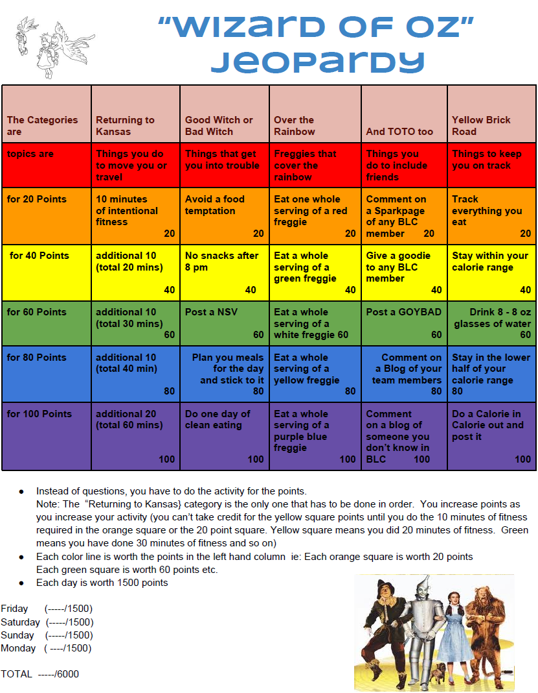
- OZ Travel & Cabana News:
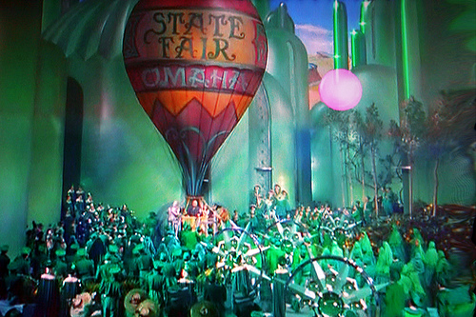
We will be meeting up with more travelers along the Yellow Brick Road and in the Forest, and participating in the Wizard of Oz Jeopardy Challenge for the weekend together. Please check your Cabana thread for Team Travel assignments! They will be posted shortly, and travel starts on Friday.
Island Blossoms:
http://www.sparkpeople.com/myspark/team_messageboard_thread.asp?board=24267x57695x50033367
Coconut Queens:
http://www.sparkpeople.com/myspark/team_messageboard_thread.asp?board=24267x57695x50033355
Sunny Beaches:
http://www.sparkpeople.com/myspark/team_messageboard_thread.asp?board=24267x57695x50033345
**Participation in the Wizard of Oz Jeopardy Challenge and Travel will earn you a new Passport Stamp to the Land of Oz! You can pick it up here:
http://azuredestinations.weebly.com/passport-stamps--island-goodies--bartenders.html
Keep alert! You never know what lurks in the woods! Lions, Tigers, and Bears! Oh My!!! Or this shady character….. eeks!
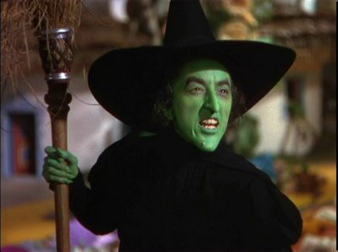
- Motivation Station! 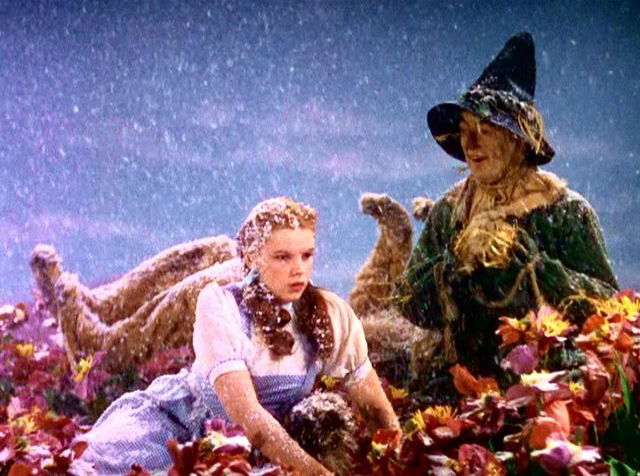
Words of the week: Home, Courage, Brains, Heart, Bad Witch, Good Witch, Road, Wizard

The characters of the Wizard of Oz certainly had their deepest desires obvious for all to see. Dorothy wanted to go home, the Lion wanted Courage, the Tin Man, a heart, the Scarecrow, a brain, the Bad Witch wanted control, the Good Witch wanted to help everyone, and the Wizard (eventually) to just be himself.

Many of us can identify with these desires as we live our lives, especially on our Journey to health. You want to have a great life, living it as you envision, making healthy choices, looking and feeling great, making a happy home and things good for those around you- family, friends, and sometimes people you barely know!

While it is admirable to strive for the best and have weight loss goals of what you want to look like (or weigh) someday, never lose sight of yourself- you are unique, and have a lot to offer this world- just by being who you are! Weight loss and exercise will help you feel better mentally and physically, but deep inside, who you are is separate from what you look like. Embrace you for who you are now! And remember not to compare yourself to others- what works for another, may not be right for you.

Have the COURAGE to face down any negative self-talk, and replace “I can’t” with “I can, and WILL”! Because the biggest battle comes from within. YOU are the only one holding you back.

Cowardly Lion: Courage! What makes a king out of a slave? Courage! What makes the flag on the mast to wave? Courage! What makes the elephant charge his tusk in the misty mist, or the dusky dusk? What makes the muskrat guard his musk? Courage! What makes the sphinx the seventh wonder? Courage! What makes the dawn come up like thunder? Courage! What makes the Hottentot so hot? What puts the "ape" in apricot? What have they got that I ain't got?
Dorothy, Scarecrow, Tin Man: Courage!
Cowardly Lion: You can say that again! Huh?

Dorothy: Your Majesty, if you were king, you wouldn't be afraid of anything?
Cowardly Lion: Not nobody! Not nohow!
Tin Man: Not even a rhinoceros?
Cowardly Lion: Imposerous!
Dorothy: How about a hippopotamus?
Cowardly Lion: Why, I'd thrash him from top to bottomus!
Dorothy: Supposing you met an elephant?
Cowardly Lion: I'd wrap him up in cellophane!
Scarecrow: What if it were a brontosaurus?
Cowardly Lion: I'd show him who was king of the forest!


- Island Extras: 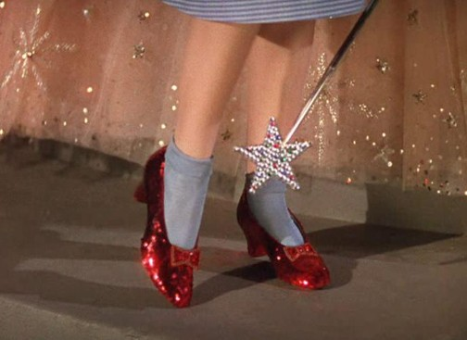
Don’t forget to wish Misty (1LBDOWN) a Happy Birthday on Wednesday (10/24)!
Quote: ~from the Wizard of Oz! (of course)
Tin Man: What have you learned, Dorothy?
Dorothy: Well, I - I think that it - it wasn't enough to just want to see Uncle Henry and Auntie Em - and it's that - if I ever go looking for my heart's desire again, I won't look any further than my own back yard. Because if it isn't there, I never really lost it to begin with! Is that right?
Funnies!
 | 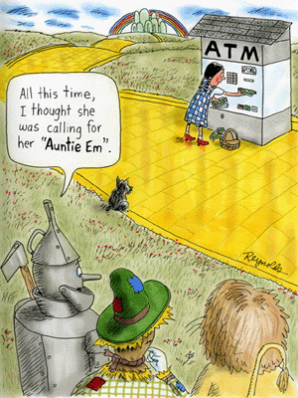
Once you complete all the steps and make it to Oz, your hot air balloon will appear to transport you back to the Island on Tuesday! Good luck for week #7!
~Ursula/ Seven~

