Azure Beachcomer & Cabana News
 | “ABC News”

Aloha Azuritas and welcome to Week #8. Please bid farewell to your wonderful host teams from last weekend, if you have not already, and make your return back from Oz. If you missed your return balloon flight,  you know what to do! That’s right – use the ruby slippers! 
We have received awesome, positive feedback from our host teams regarding your visits during the weekend – You girls did a great job with your travel assignments!! Way to go! You represent us and share our Team Vision so well! Thank you!

Well, by now you probably have yourself in a regular routine after these past 7 weeks. But is it working for you? Are you making progress toward your main goal here, or are your still stopping your own success with partial efforts and excuses for eating poorly? There is STILL TIME to turn it around and make a final push!

Let me recommend the No Excuses Clean-Eating Challenge starting November 1st through November 30th. You won’t regret it! Get your fill of “whole foods” and watch the weight drop off! Sign up today, if you haven’t already!

http://www.sparkpeople.com/myspark/team_messageboard_thread.asp?board=24268x57695x50624042





WEEKLY TRACKING SHEET
WED. 10/31 - TUES. 11/6

WEEKLY DATA:

 | WED | THU | FRI | SAT | SUN | MON | TUE | TOTAL
WEIGH-IN |  | XXX | XXX | XXX | XXX | XXX | XXX | XXX
POSTED IN CHAT: | Y/N | Y/N | Y/N | Y/N | Y/N | Y/N | Y/N | ____/7
STRONGend GOALS MET?: | XXX | XXX | Y/N | Y/N | Y/N | Y/N | XXX | ____/4
FITNESS MINUTES:  STILL A STREAKER?  (5X per week, 20 min +) |  |  |  |  |  |  |  | ________  MINUTES
No Excuses Clean Eating Challenge | XXX | Y/N | Y/N | Y/N | Y/N | Y/N | Y/N | ____/6
CICO |  |  |  |  |  |  |  | XXX


Important News:
- Weigh-in is Wednesday, October 31st! Your post is due by midnight in your time zone!
Please follow this link, copy the template, and reply to post your own template. Fill in last week’s weight, this week’s weight, and the +/- difference, as well as your overall BLC +/- total!
http://www.sparkpeople.com/myspark/team_messageboard_thread.asp?board=-1x57695x49526866

- Posting in the Team Chat! Remember, it is a REQUIREMENT to post at least 3 times per week (or more) on the Azure Chat thread.
http://www.sparkpeople.com/myspark/team_messageboard_thread.asp?board=24174x57683x49504004
This is a BLC rule!
- Wizard of Oz Jeopardy Challenge-
Please log your points here, asap, if you haven’t already!
http://www.sparkpeople.com/myspark/team_messageboard_thread.asp?board=24268x57695x50579551
- STRONGENDS
If you are doing them week to week or have not yet posted plans, don’t forget to pre-plan this coming STRONGend! Remember, you can revise as well!
- No Excuses Clean Eating Challenge!
Sign up here, if you're in for the No Excuses Clean Eating Challenge for November 1st -30th !
http://www.sparkpeople.com/myspark/team_messageboard_thread.asp?board=24268x57695x50624042
Everybody is welcome to join! (but it is not required) You don't have to go all the way to the WHOLE 30 eating plan, but make a commitment to yourself to avoid something you KNOW isn't good for you! Is it fast food? Deep fried? Too much sugar? Soda? Go 30 days without something that is holding YOU back!
- Idea! Did you participate in the Wizard of Oz Challenge square “Calories In, Calories Out” this past weekend? If you did, you know that it’s a great tool to see how your calorie torching is going! If not, consider trying it out. For more information, see:
http://azuredestinations.weebly.com/calories-in-calories-out-cico.html

This week’s challenge will be posted in the chat thread by
Jenny (FITNFUNJEN).
Please stay tuned!



Azurita Travel & Cabana News:
Week #8 is a non-travel week, however we may have some visitors! Please go out of your way to welcome them. You know how it’s no fun if you post on another Team and NO ONE acknowledges your existence? Maybe they are busy or don’t know you, but no one makes any effort to even say hi? Well let’s not let that happen on Azure- Let them know you are glad they stopped by, check out their SparkPage, leave a goodie, make a friend, etc. ANYTHING so that they know you care that they took the time to come chat with us.
OH, and the Cabanas need cleaning, so the youngest person in each Cabana is assigned to that. 

Motivation Station! 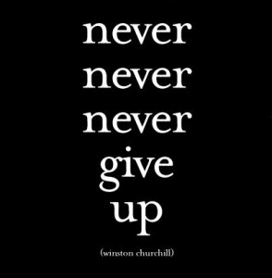

Word of the week: Perseverance!
I may not be there yet, but I'm closer than I was yesterday. ~Author Unknown
Perseverance is not a long race; it is many short races one after another. ~Walter Elliott, The Spiritual Life
You know what you want. You know how to get it. But sometimes… it’s not as easy as that. We encounter so many road blocks in this weight loss journey, it’s a wonder that we ever make progress. Yet, if we keep on chipping away, we are bound to get there eventually. Don’t lose hope if things aren’t going as well as you thought. Let go of whatever has happened before now, and move forward with a new outlook. You can succeed, you will do this, you are a winner! And it is definitely worth it. Let each day be a new beginning so you may try your best again, without holding on to any failures of the past.
Keep up your motivation and inspiration by taking a daily dose of SparkPeople and regular visits to Azure Destinations! Share your thoughts, your successes, your questions, your tips, and read and “listen” to what others have to offer. You may learn something along the way that will change everything for you!
All the best for your future health and happiness. 

Island Extras: 
Quote: Our greatest glory is not in never failing, but in rising up every time we fail. ~Ralph Waldo Emerson
Funnies!
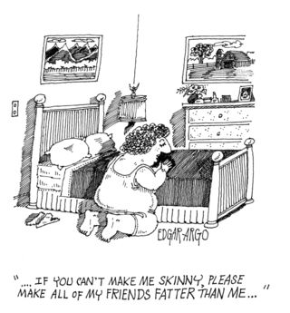 | 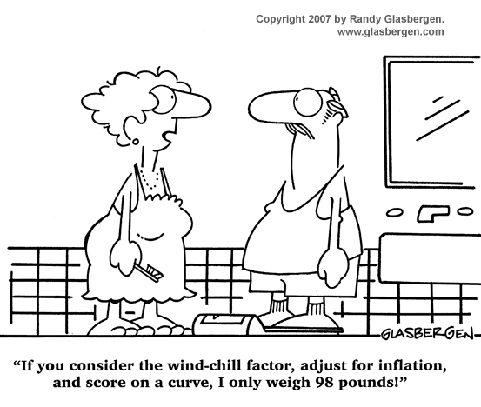

Have an awesome Week #8! Keep going…
~Ursula/ Seven~

